Experiment – 5
Write a program for Implementation of K-Nearest Neighbours (K-NN) in Python

Aim
To implement the K-Nearest Neighbours (K-NN) algorithm in Python and classify data based on the nearest data points.

Algorithm
- Load the dataset.
- Separate the features and target class.
- Split the dataset into training and testing data.
- Choose the value of K.
- Calculate the distance between the test point and training points.
- Select the K nearest neighbours.
- Assign the class based on majority voting.
- Evaluate the model accuracy.
Program:
from sklearn.datasets import load_iris
from sklearn.model_selection import train_test_split
from sklearn.preprocessing import StandardScaler
from sklearn.neighbors import KNeighborsClassifier
from sklearn.metrics import accuracy_score, classification_report

iris = load_iris()

X = iris.data
y = iris.target

X_train, X_test, y_train, y_test = train_test_split(
X, y, test_size=0.2, random_state=42
)

scaler = StandardScaler()
X_train = scaler.fit_transform(X_train)
X_test = scaler.transform(X_test)
k = 5
knn = KNeighborsClassifier(n_neighbors=k)
knn.fit(X_train, y_train)
y_pred = knn.predict(X_test)
print("Actual Values:")
print(y_test)
print("\nPredicted Values:")
print(y_pred)
print("\nAccuracy:", accuracy_score(y_test, y_pred))
print("\nClassification Report:")
print(classification_report(y_test, y_pred))
sample = [[5.1, 3.5, 1.4, 0.2]]
sample = scaler.transform(sample)
prediction = knn.predict(sample)
print("Predicted Class:", iris.target_names[prediction][0])
Output:
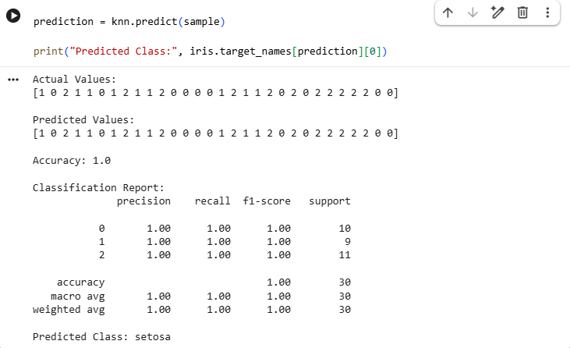

Result
The K-Nearest Neighbours (K-NN) algorithm was successfully implemented in Python and used to classify Iris flower species. The model achieved high classification accuracy by identifying the class based on the nearest neighbouring data points.

